CADDER CHURCH
GROWTH PLAN

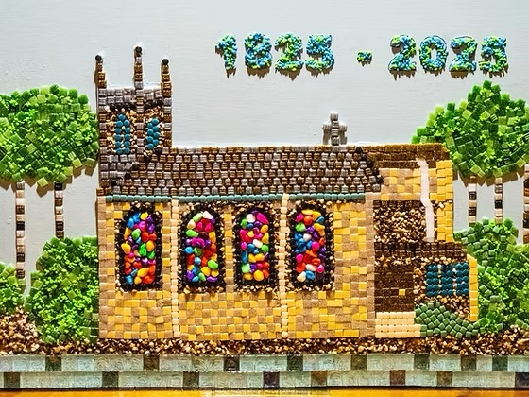

ANNUAL REPORT 2025

CADDER CHURCH GROWTH PLAN: ANNUAL REPORT 2025

INTRODUCTION

The Church of Scotland has asked all churches to focus on the ‘5 Marks of Mission’ which are: 1. To proclaim the Good News of the Kingdom (Tell); 2. To teach, baptise and nurture new believers (Teach); 3. To respond to human need by loving service (Tend); 4. To seek to transform unjust structures of society (Transform); 5. To strive to safeguard the integrity of creation and sustain and renew the life of the earth (Treasure).

Over the last few years, Cadder Church has taken a new approach to how it works towards advancement of the Marks of Mission. Since 2023, we have prepared an annual ‘Cadder Church Growth Plan’. The Growth Plan approach aims to give us a structure through which to grow our Church. It puts Mission and the Gospel of Jesus on the front foot, supported by Resources. We recognise that Finance, Risk Management and Property resources provide the solid foundations from which we can pursue our church mission.

We have 12 teams focused on the Marks of Mission (Appendix 1). The teams, working collaboratively, contribute to more than one Mark of Mission

Through the Growth structure we aim to nurture what we have and to sow seeds for the future. We have a Vision of how we want our church to look in the years ahead – “A Vibrant Part of God’s Jigsaw” (Appendix 2). Our Vision is rooted in the Marks of Mission.

In addition to all the teams involved in delivering the Growth Plan activities we know it is very important to acknowledge the work of the many other people and organisations around the church who contribute so much to the life of Cadder. They are all key parts of the ‘Cadder Jigsaw’ and include: our Kirk Session, the Guild, Boys Brigade, Girls Brigade, Men’s Club, our Organist and Choir, Cadder Singers, the Flower arrangers, our Church Officers, those involved with letting our halls, the people who clean the sanctuary after worship and the people who care for our church grounds. All contribute to the advancement of God’s Kingdom at Cadder.

CADDER 200

In 2025 we celebrated 200 years of worship and fellowship in our current church building. 200 years on a site where Christians have gathered for nearly 900 years. A small team of people planned and ran events celebrating this significant milestone in the life of Cadder Church. A competition was run to design a special Cadder 200 logo. The winning logo, shown in Appendix 3, was created by a member of the congregation and was based on the main window in the church chancel. The logo appeared on bicentennial communications, literature, the church website and celebratory merchandise. Our Cadder Kids group created a beautiful mosaic picture of the church, shown on the front page of this report. The mosaic has been framed and hung in the church vestibule. A lasting contribution by the children to the fabric of our 200 year old sanctuary.

During the year there were many opportunities to come together to share fellowship and celebrate the 200th anniversary of the church. A highlight was a memorable evening Service of Thanksgiving held in the church in August. We were joined by the Moderator of the Church of Scotland who preached the sermon and by the Moderator of Glasgow Presbytery. Also in attendance were ten former Cadder ministers, ministry probationers and students who had placements at Cadder between 1984 and the present day. They travelled from all around the country, from the Highlands to the Borders to share many moving, and at times hilarious, memories of their time at Cadder. They all spoke of how their experiences at Cadder had influenced their ministries.

Through the year we had a special performance in the church by the Glasgow Philharmonic Male Voice Choir, a canal cruise leaving from the jetty beside the church, a Joseph and the Amazing Technicolour Dreamcoat singalong in church and a Desert Island Discs night in church involving members of the congregation. An exhibition of artefacts and pictures showing ‘Cadder Church Through the Years’ was run in the South Hall. The final celebratory event in November was a musical night held in the church featuring our organist, a guest baritone singer, young pipers from the area and young musicians from the local secondary school.

A commemorative booklet with pictures of the year’s celebrations has been published and shared with all members of the congregation. A special addition to the Cadder archives. We thank the planning team for enabling us to come together to give thanks for the service of generations in our beautiful sanctuary as we look to continue that service into the years ahead.

WHAT WE HAVE BEEN DOING TO TAKE FORWARD THE 5 MARKS OF MISSION

The Growth Plan 2025 was made up of many things which are core to our church life each year, but also some new things which brought different opportunities for worship and fellowship. It was a plan which everyone could contribute to, participate in, or pray for as we looked forward in faith. Here we reflect on some of the things we did in 2025 to advance the Marks of Mission.

Mark of Mission 1: To proclaim the Good News of the Kingdom

We continued to worship together in our beautiful and peaceful sanctuary every Sunday. A place for reflection and praise, music and fellowship, the church is central to our spiritual life at Cadder. We also enjoyed opportunities to worship at different times. Between January and April we worshipped during the week, every Tuesday and Thursday morning, at an early fellowship meeting which people could attend in person or join through Zoom from their homes. Through Lent, a series of Lent studies was held each Wednesday morning in the South Hall chapel. During Holy Week in April, we participated in local church services joining with other churches in the area. In May we took part in Christian Aid services with other local congregations. They joined us again in November for the Remembrance Sunday service. These are important opportunities to connect the boys and girls with the worshipping life of the church. The autumn period saw us celebrate Harvest together as we moved along to the season of advent when the church was busy with our gift service, nativity, grief share service, carol concert led by the Cadder Singers (supported by boys from the Boys Brigade), carols and readings service and watchnight service.

In 2024 the Worship and Spiritual Leadership team installed screens in the sanctuary. This has opened up new opportunities for worship and music. At the start of 2025 new microphones were obtained and a rack system set up in the control desk area at the back of the sanctuary. The control desk area was extended by the removal of a pew and a larger desk installed to give more space to the team operating the equipment. Mobile wi-fi has been set up in the church which allows online sharing of the service. The service is uploaded to YouTube after worship on a Sunday morning. A licence for Fischy children’s music has been obtained for use in the sanctuary and church halls.

The Communications team published quarterly editions of the Cadder Gazette helping to share news of what had been going on around the church and upcoming events. The team continued working on redevelopment the Cadder Church website at the start of 2025 and the new website was launched in April. The team continues to monitor and update the site based on feedback and content requests. Enquiries are now being received using the web form available through website, the majority being hall booking enquiries. This is proving to be a good communications channel for people who are not directly involved with the church. The team managed Facebook posts to the Cadder Church page and uploaded the Sunday morning service to YouTube each week. The team also created a dedicated ‘Cadder 200’ page to help promote the church bicentenary celebrations.

Mark of Mission 2: To teach, baptise and nurture new believers

We enjoyed all age worship at church through the year with our children taking part in the first part of the Sunday service before heading up the hill to the North Hall to continue fellowship, stories and crafts. We have a strong group of children who take part in Cadder Kids activities on a regular basis, brought to church by parents and grandparents.

Another happy Cadder Family Indoor Street Party was hosted in the South Hall in June by the Nurture and Care & Fellowship teams. Cakes, ice cream, games and bunting were enjoyed by the 50 or so attendees of all ages who came along. The Nurture team served around 35-40 children with juice, crisps and hot dogs following the Brigades closing and opening parades. The 2025 Christmas party saw all the Cadder Kids go together to an activity centre, Inoflate, in Cumbernauld. There was snacks and juice for the children while parents were able to sit together and catch up in the party room. There were 23 children in attendance. A highlight of the Advent season was the nativity play presented in church by Cadder Kids, Jesus’ Birthday Party, complete with a disco ball, party hats, tooters and dancing in the aisles.

In addition to our Sunday Cadder Kids activities, The Nurture team offered opportunities to families within the church and in our community to connect with our church through the week, through the year. Messy Play ran on Tuesday and Thursday mornings for pre-school age children during school term periods. Between 15 to 18 children attended each session with an accompanying adult. At times there was a waiting list to attend. Chat and Play sessions ran on the first Saturday morning of the month when around 40 children and families came together to enjoy fun and fellowship. Each month’s Chat and Play is themed. Crafts and activities were provided for the children and tea, coffee, cakes and snacks were served in the Coffee Shop. A gardening activity was run jointly by the Nurture and Caring for Creation teams as part of Chat and Play activities with the children getting the opportunity to build bug houses and plant seeds and flowers for the bees. The cost of running both Messy Play and Chat and Play was more than covered by donations from the families attending.

Our very active and well attended Boys and Girls Brigade companies continue to enrich our wider church life. In February, the Boys Brigade ran their highly popular annual quiz night while the Girls Brigade held their second Cadder ‘Kurling’ competition which was once again hotly contested by teams drawn from groups around the church. This is now a much anticipated annual fixture in the church year’s calendar of events. This year’s victors were the Men’s Club. The Girls Brigade ran a very busy Coffee Morning in March with Easter themed crafts for sale. In May, the Boys Brigade held their annual plant sale once again enabling our members to refresh their gardens while supporting company funds. Sections of both the Boys and Girls Brigade enjoyed early summer trips and camps to end the 2024/25 session. The Boys and Girls Brigades came to church in May to mark the end of another busy session of activities and were then back in September at the start of the 2025/26 session for their opening parade.

Mark of Mission 3: To respond to human need by loving service

The Care and Fellowship team has offered pastoral care in a number of ways during 2025, including the Pastoral Post Box and life event cards. The Pastoral Post Box is available in the church each Sunday to help identify people who may appreciate contact from the team or with the Minister, latterly our Locum Minister. The First Monday Club was attended by 25-30 attendees who enjoyed a varied syllabus of speakers, crafts, films and an outing to the Riverside Museum. Film nights were hosted in the North Hall, very popular events with around 35 – 40 people attending. Visits to care homes and telephone calls were offered as part of caring and loving service to members of our congregation. The team delivered around 40 harvest flower arrangements to members of the congregation and provided a Harvest lunch. Generous food and monetary donations were collected for Lodging House Mission in Glasgow.

The Church Coffee Shop plays a very important part in pastoral care and outreach to the community. Open 4 days a week through the year, led by our Coffee Shop Manager, a dedicated team of volunteers served coffees, teas, baking and lunches in our South Hall in the heart of Bishopbriggs. In May, the Coffee Shop Team once again played a key role in organising use of the South Hall in support of the Bishopbriggs Community Day. This was very successful, bringing many people to the hall and making them more aware of our presence in the community. Contributions were made by other Cadder Church teams and organisations which ran a range of stalls and activities. Alongside the Coffee Shop, the Retail Shop has offered a range of goods to people coming into the South Hall during Coffee Shop opening times. The Retail Shop team work hard to source goods locally and beyond. The Retail Shop team also supported the Community Day as part of the South Hall fun and games. In October the Shops opened on a Saturday as part of our Christmas Shops Open Day which saw a range of stalls set up in the South Hall selling various crafts and goods, including cards and gifts from the Retail Shop. In December, Christmas menus were served in the Coffee Shop alongside a slightly restricted normal menu for all customers. About 120 Christmas meals were served over 6 days during a 2 week period. A huge effort on the part of the Coffee Shop Manager and volunteers.

Mark of Mission 4: To seek to transform unjust structures of society

We had a busy Christian Aid week in May, coming together with other local congregations to worship and pray for our world and to raise funds to support the work of the charity. The Bishopbriggs churches cluster group comprising Cadder, Kenmure and Springfield Cambridge collected £4300 for Christian Aid. £400 of the total sum was raised through a Christian Aid quiz night hosted in Cadder South Hall. Through the Early Fellowship Group which came together on Tuesday and Thursday mornings between January to April we prayed for people and places locally, nationally and world-wide who are facing challenges in all sorts of ways, including: poverty, famine, war, poor health, discrimination, loneliness, political and religious oppression.

The Community and World Outreach team collect weekly donations for our local foodbank throughout the year. In September the team organised our participation in the annual East Dunbartonshire Doors Open Day event. We had a number of visitors to the church, local and from abroad, who enjoyed the beauty and peace of our sanctuary, a warm welcome and a cup of something warm with a bit of cake. There were also some impromptu organ recitals on the day by visitors.

In November the Community and World Outreach team organised the annual Samaritan’s Purse Shoebox Appeal collection in the church. 47 boxes were donated. Working alongside the Care and Fellowship team, the team organised our December Gift service appeals for the Daisy Chain charity and East Dunbartonshire Women’s Aid. Alongside donations amounting to £300, we collected sensory toys for Daisy Chain. Donations totalling £210 were collected for Women’s Aid together with 75 pairs of children’s pyjamas.

Mark of Mission 5: To strive to safeguard the integrity of creation and sustain and renew the life of the earth

In March, the Caring for Creation team led a Saturday evening Earth Hour service in church and helped lead to a Sunday morning climate change service. Both services were well received. Also in March, the team participated in a Chat and Play session where their eco activities were enthusiastically received.

In May, the Caring for Creation team hosted a Climate Change Conference which included presentations from Val Brown of Christian Aid Scotland and pupils from Meadowburn Primary School. The children had put a lot of work into their presentation which made us think about how our world’s resources are used and misused. The event was also attended by our local MP, Susan Murray, who spent time speaking to the children and participants.

Litter picks were organized around church buildings and tree planting was encouraged through the Cadder Gazette. Wildflower seeds were distributed at church in October / November and to Cadder Kids and the Brigades for planting in November and Spring 2026.

Caring for Creation information boards were regularly updated encouraging the congregation and hall users to think about our environment and actively recycle. Recycling boxes are in regular use around the church and proving to be very worthwhile. East Dunbartonshire Council recycling guidance has been placed on our new church website.

SECURING THE FOUNDATIONS

In addition to the work of the Mission teams, the Resources teams have been busy throughout the year. The Property Team has taken care of our buildings carrying out a wide range of repair and maintenance works. Boiler services were carried out at the church, North and South Halls. The organ in church was tuned. Fixed wire testing and alarm and fire extinguisher testing were carried out. All buildings step edges were painted to highlight edge. Anti-slip treads were applied to steps at the vestry entrance to the church. At the North Hall, carpet tiles were removed at the entrance and the concrete floor was painted with floor paint. While we are in vacancy, the church Manse will lie empty. A Condition Schedule was carried out and submitted to our insurers and to Glasgow Presbytery. The Property team began carrying out weekly inspections of the Manse in Quarter 2 which are required for insurance purposes and these continued through the remainder of the year as required. Church cleaning was undertaken by a group of volunteers who clean the church weekly through the year. Hall lets remain busy and a are providing a regular source of income for the church. We are grateful to our Hall Manager who takes on this considerable task.

The Finance and Risk teams have manged our finances and risks around the church. The 2024 accounts were prepared and audited in the first quarter of 2025 and presented to the congregation at the annual stated meeting in June. The Fabric Fund appeal was conducted in March. Church collections; gift aid and appeal counts have been managed as required. The annual review of salaries, fees and rentals was completed at the end of the year. One of the key responsibilities of the Risk Team is to ensure the church is compliant with Church of Scotland safeguarding requirements. Safeguarding records were presented to Glasgow Presbytery for inspection as part of the annual church records inspection. In June, the Risk Team conducted Fire Safety Risk Assessments for the church, the North Hall and the South Hall. A number of Trustees completed the required Trustee Safeguarding training course through the year.

Teams have spent within their allocated 2025 budgets. The Nurture team continues to generate funds for their work with children and families due to generous donations made by those attending Messy Play and Chat & Play sessions though the year. Budget spend for will be accounted for in the preparation of the church annual accounts prepared by the Finance Team.

REFLECTION ON THE YEAR

The Annual Report 2025 reflects another busy year around the church as we worshipped together, shared fellowship, laughed together and grieved together. We prayed and cared for our church, our community and our world in challenging times. Our church life at Cadder is the sum of many parts, contributed to by many people across the generations. A special year in the life of our church as we celebrated 200 years in our current building.

The year has had its challenges. Our Minister, John MacGregor, retired from full-time ministry in April 2025. John was a key figure in the development and introduction of the Cadder Growth Plan. His inspiration and leadership brought us through many challenging times, including the period of the Covid pandemic. He helped us grow as a church, in worship and fellowship. In particular, he nurtured a small group of parents, encouraging them to bring their children to church on Sunday and to other church child focused activities. We are now blessed to have a group of around 16 children who come about the church regularly and enrich our church family. They give us hope for the future. We give thanks for John’s ministry at Cadder and for the unstinting work of his wife, Susan, who contributed so much to the life of our church.

Following John’s departure, a linkage with our friends and neighbours at Kenmure Church, Bishopbriggs was progressed. This will now be the way forward for Cadder and will provide the opportunity to call a Minister, shared with Kenmure, hopefully in 2026. While we are now in a period of inevitably unsettling change, we have secure foundations here at Cadder Church, rooted on the same spot for nearly 900 years – and we have a plan for the future. Work on the 2026 Growth Plan is already well underway.

Thanks to all who worked so hard to deliver the Growth Plan for 2025 and to those who offered encouragement and support to the teams as they delivered their activities. Despite the changes and challenges we have faced, across the congregation we have all pulled together and pushed on with our service to the church and our community. Through this period of change we are grateful for the support and service of our Interim Moderator and Locum Minister.

May God be in all we do as we continue to work together to advance the 5 Marks of Mission.

APPENDIX 1: CADDER CHURCH GROWTH STRUCTURE 2025

 | KIRK SESSION
 | CADDER GROWTH COMMITTEE

MISSION Groups / Teams | RESOURCES Groups / Teams
Tell & Teach Group: Worship & Spiritual Leadership Team | Stewardship Group: Finance Team
Tell & Teach Group: Nurture Team | Stewardship Group: Risk Team
Tell & Teach Group: Communications Team | Property Group: Property Maintenance & Development Team
Tend & Transform Group: Care & Fellowship Team | Property Group: Hall Management & Marketing Team
Tend & Transform Group: Community & World Outreach Team

Tend & Transform Group: Coffee Shop Team
Tend & Transform Group: Retail Shop Team
Treasure Group: Caring for Creation Team

APPENDIX 2: A VISION for CADDER CHURCH - A VIBRANT PART OF GOD’S JIGSAW

In 5 years’ time, Cadder’s ministry will come together like a jigsaw puzzle, revealing the picture of a vibrant, dynamic church at the centre of our community
The spiritual life of the church will be strong and deep, offering multi-generational worship and fellowship opportunities. Worship will take many different forms. Everyone, regardless of age or experience, gets to take part and is encouraged to bring their own particular piece of the jigsaw.
We will communicate around and about the church in a wide variety of ways. The church will be open to individuals and groups of people both online and in person. It will be known as a place where support is offered with kindness and sensitivity. It will be seen as an anchor point in the community which it serves.
The feeling will be that of a family where everyone looks out for everyone else. Our focus on care and community will make Cadder a place where people feel they belong. The church will radiate love and acceptance and when people come alongside us they will be seen to add new and vibrant parts to an ever growing jigsaw.
Cadder will be a church which cares about creation. We will actively work to reduce our impact on the planet and will engage with other likeminded people and organisations to be a catalyst for change in the community. It will be a church which is known for being willing to pioneer things which enable change in society. By its actions it will help shape that piece of the jigsaw which is the church’s part in social justice and reform.
In 5 years’ time, Cadder will be a church which is Growing. It will be seen as a Jesus centred community where everyone values each other and treasures God’s Word and World.

APPENDIX 3: The CADDER 200 Logo

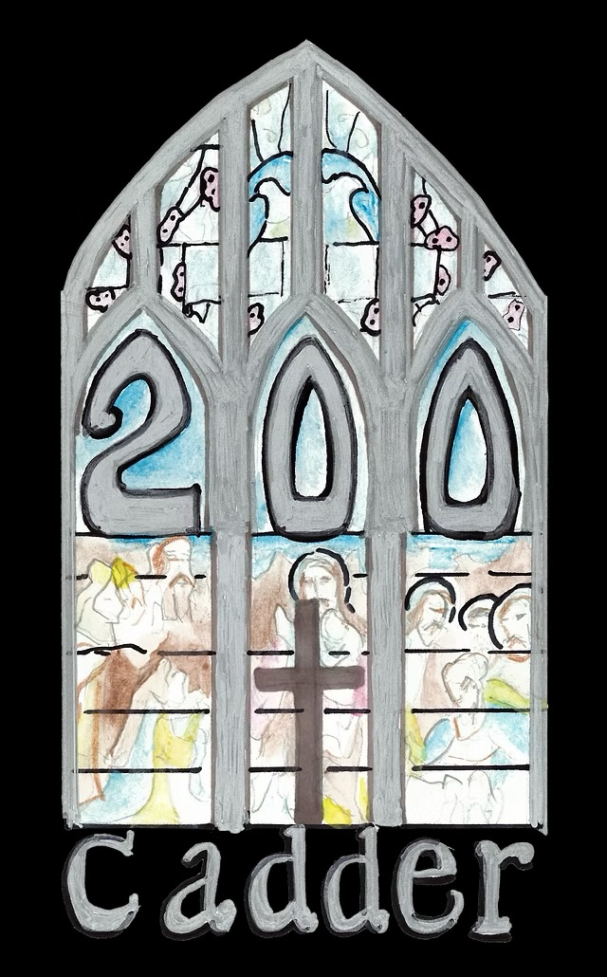

The Cadder 200 logo was designed by church member and elder, Tracy Gibson.

